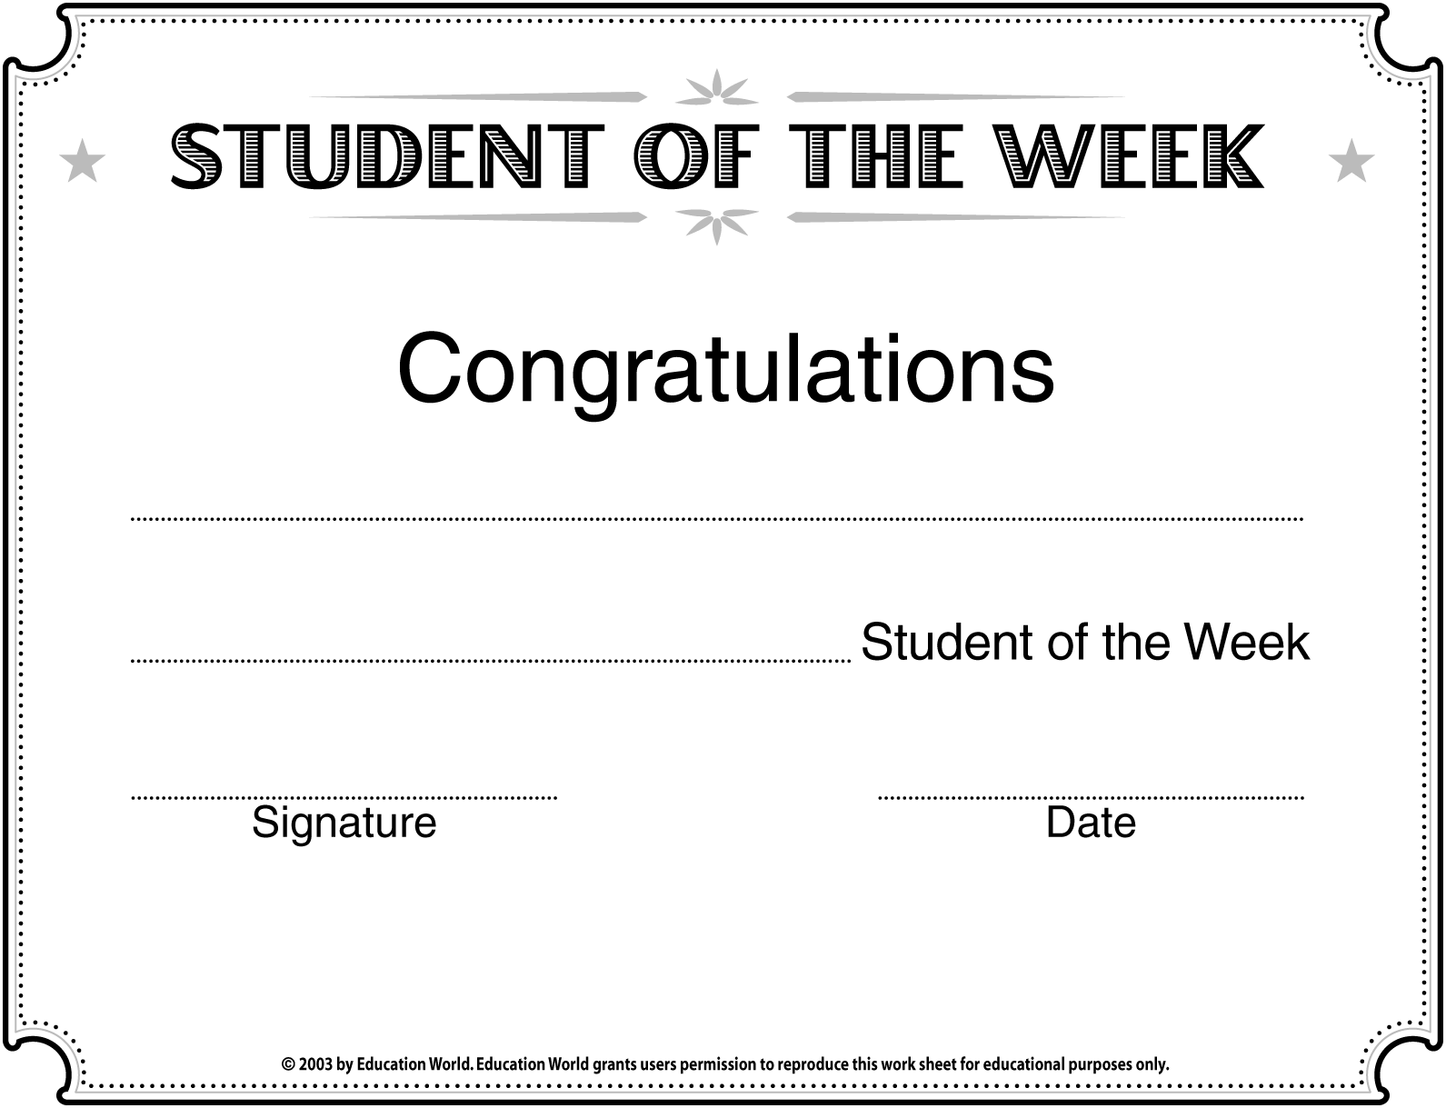
Insert STUDENT’S NAME here
Insert SUBJECT here

Insert SCHOOL/CLASS NAME here


