 |  | 

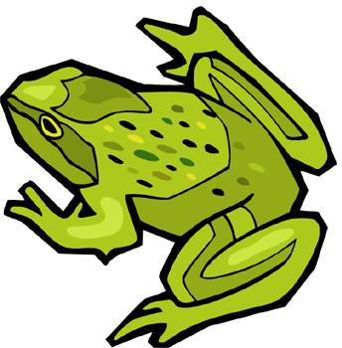  Frogs | 

  Bears | 


Swans


Elephants


Cats

