

Connect the dots by following your ABCs

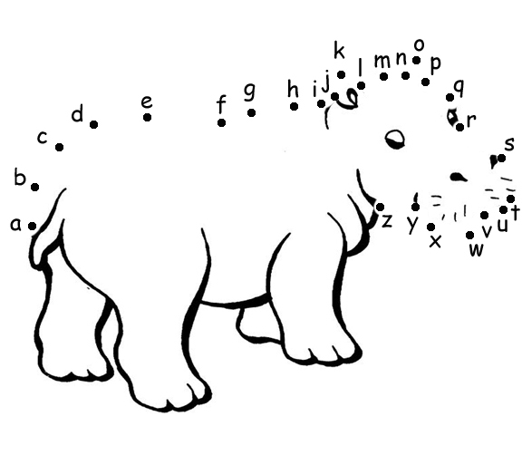

© 2004 www.bogglesworld.com

