

 |  | Across  2. These keep your feet dry.  4. Winter weather.  5. Wear this to keep warm.  7. These keep your ears warm.  10. ______ degrees Celsius: freezing.  11. A winter activity on snow.  13. First month of winter.  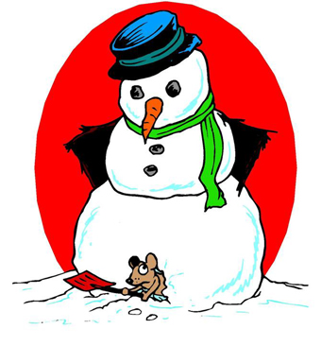 |  |  |  | 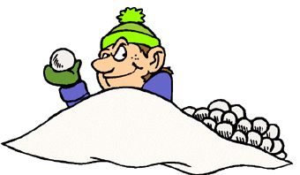

Down
1. These keep your hands warm and dry.
3. This keeps your neck warm.
6. This covers your window.
8. What ponds do in winter.
9. This covers the ground.
12. This covers ponds and lakes.
www.bogglesworld.com

