

 |  | Across  3. A winter activity on ice.  4. A winter person.  6. What ponds do in winter.  7. This keeps your neck warm.  9. A winter activity on snow.  11. First month of winter.  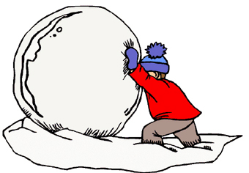 |  |  |  | 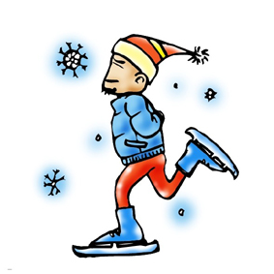

Down
1. This covers your window.
2. These keep your ears warm.
3. This covers the ground.
5. You can ride this.
8. Winter weather.
10. This covers ponds and lakes.
www.bogglesworld.com

