Unscramble these snowflakes to figure out the hidden message:
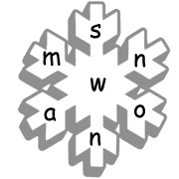 | 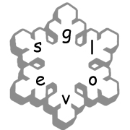 | 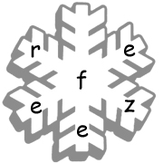
__ __ __ __ __ __ __  4 11 | __ __ __ __ __ __  6 | __ __ __ __ __ __  1 2
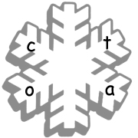 | 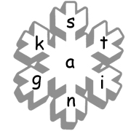 | 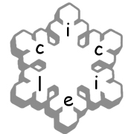
__ __ __ __  3 | __ __ __ __ __ __ __  7 | __ __ __ __ __ __  12 10
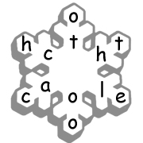 |  | 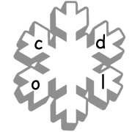
__ __ __ __ __ __ __ __ __ __ __ __  5 9 |  | __ __ __ __  15 14
Winter Riddle: Use the numbers above to fill in the riddle.
When you look out, you see it, but when you see it, you can’t look out. What is it? __ __ __ __ __ __ __ T __ __ __ __ N __ __ W

www.bogglesworld.com

