
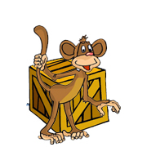 | in front of  The monkey is in front of the box.
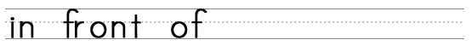
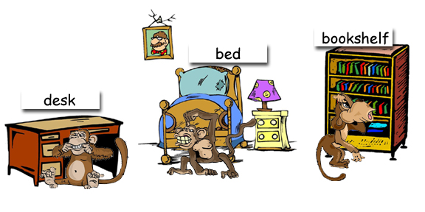

Where are the monkeys?

www.bogglesworld.com

