
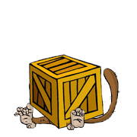 | under  The monkey is under the box.

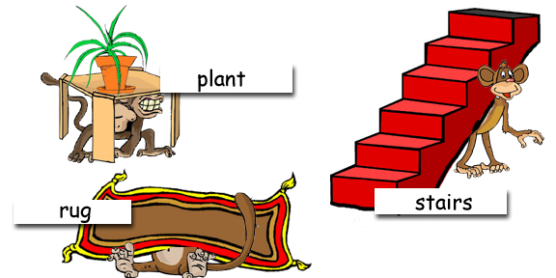

Where are the monkeys?

www.bogglesworld.com

