© 2003 by Education World®. Education World grants users permission to reproduce this work sheet for educational purposes only.
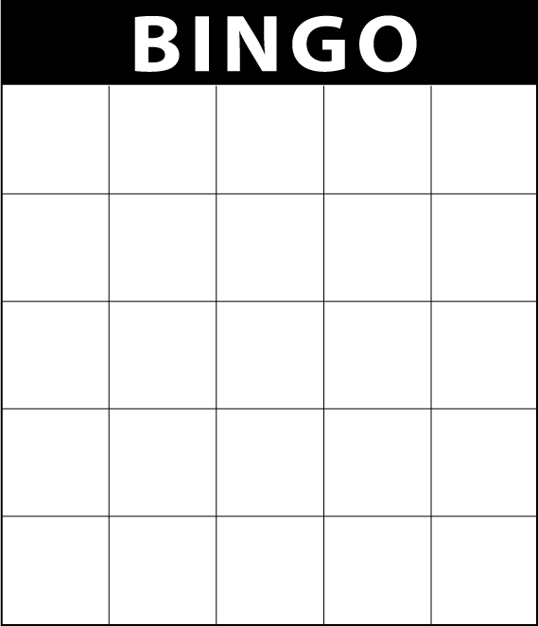
TEXT HERE
TEXT HERE
TEXT HERE
TEXT HERE
TEXT HERE
TEXT HERE
TEXT HERE
TEXT HERE
TEXT HERE
TEXT HERE
TEXT HERE
TEXT HERE
TEXT HERE
TEXT HERE
TEXT HERE
TEXT HERE
TEXT HERE
TEXT HERE
TEXT HERE
TEXT HERE
TEXT HERE
TEXT HERE
TEXT HERE
TEXT HERE
TEXT HERE

